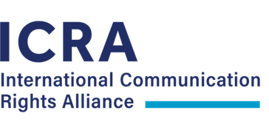

Policy statement on comprehensive communication rights for persons with communication needs

Introduction

This policy statement on comprehensive communication rights has been developed and endorsed by the International Communication Rights Alliance – an alliance led by the International Society for Augmentative and Alternative Communication (ISAAC) in collaboration with Deafblind International (DbI) and the International Council for Education of People with Visual Impairment (ICEVI).

The International Communication Rights Alliance was formed in 2020 to promote international and national awareness, entitlements and corresponding quality services for persons with communication needs.

The definition of ‘communication needs’ used by the International Communication Rights Alliance is based on the International Classification of Functioning, Disability and Health (ICF) (World Health Organisation, 2001). Specifically, the ICF component "body function and structure" which is also a key component of Walsh's (2015) model of communication well-being, will be used. Therefore, those included as people with communication needs are people who have any loss or reduction in any body function or structure that supports communication. This includes people with sensory impairments (e.g. hearing and / or vision impairment including those with deafblindness), neurological impairment (e.g. developmental delay, intellectual disability, or acquired brain injury, for example stroke), physical impairment (e.g. vocal cord injury, or cleft lip or palate) or disease (e.g. head and neck cancers, progressive neurological diseases, for example Parkinsons disease). People with lifelong or acquired communication needs are included.

Communication is a relational concept. Participation and co-construction of meaning in effective two-way communication can be affected by impairment of body structure and function, but is also dependent on personal factors such as level of education and personality, and the environment which includes skills and attitudes of communication partners, as highlighted by the models in Appendix A and Appendix B.

Communication rights and the CRPD

Communication rights are established in the UNCRPD. The Convention explicitly understands communication in a broad sense. According to the definitions in Article 2 communication “includes languages, display of text, Braille, tactile communication, large print, accessible multimedia as well as written, audio, plain-language, human-reader and augmentative and alternative modes, means and formats of communication, including accessible information and communication technology”.

When it comes to rights the Convention anchors communication in Articles 12, 21, and 24 i.e. equal recognition before the law, the right to freedom of expression and opinion and access to information, and access to education at the same time as the rest of the community.

Article 21 includes the freedom to seek, receive and impart information and ideas on an equal basis with others and through all forms of communication as defined in Article 2, depending on the choice of the individual person with disability. Article 24 requires state parties to recognise the right of people with disability to education, and promotes all forms of communication (including augmentative communication) as a vehicle for achieving this right. At the center of Article 12 of the Convention, equal recognition before the law, is the notion that everybody has the right to live an autonomous life and importantly the right to be supported to do so.
An acknowledgment and consideration of communication is fundamental to this support and therefore communication lies at the center of State Parties’ obligations under Article 12.

Underpinning all Articles of the Convention is the need for effective communication.
This includes, but is not limited to the means to communicate as described in Article 2. Communication does not occur in a vacuum, it requires a communication partner, receptive and expressive components and a shared means of communicating (See Appendix B.).

The Challenge: Comprehensive Communication Rights

Persons with communication needs are diverse in resources, needs and life situations, and these constantly change across the life span.

Individually they need competent communication partners, supports for aided and/or unaided communication together with appropriate assistive technology, including dedicated Voice Output Devices available and financed at the time, place and in all their communication environments.
If not guaranteed, the CRPD rights to equal recognition before the law, the CPRD right to freedom of expression and opinion and access to information and the CRPD right to education are infringed.

Comprehensive communication rights are pervasive across all life domains, and necessary to fully operationalise all articles of the CRPD.

Call to Action
Therefore, our Call to Action is:

- Committee on the Rights of Persons with Disabilities (CRPD)

1. To takes note of our position and to use it as guidance within the work of the CRPD committee.
2. Strongly encourage the inclusion of actions and strategies by States and the inclusion of corresponding disaggregated data in relation to people with comprehensive communication needs.
3. To raise awareness of comprehensive communication needs and the corresponding needed unique and specialised competencies and assistive technologies.

- Governments of signatory countries to the CPRD

1. Include in reports to the CPRD, actions, strategies and corresponding disaggregated data in relation to people with comprehensive communication needs.

C. Governments at all levels

1. To ensure that the comprehensive communication rights of persons with comprehensive communication needs are met adequately at all ages - through specialised quality programs, and services, access to assistive technologies and secured financing of required supports.
2. To promote and support public education campaigns that raise awareness about comprehensive communication rights and the specialised programs and services required for people with comprehensive communication needs to fully participate in their community.

D. Teaching institutions and schools

1. To improve awareness of comprehensive communication rights.
2. To foster a fundamental knowledge and basic competence and provide all the information necessary to collaborate with specialised programs and services

E. Specialised programs and services

1. To keep and increase providing information, expertise and quality services relating to unique and comprehensive communication rights.
2. To mobilise their members and motivate the public to support this advocacy and awareness initiative on comprehensive communication rights.

F. Private companies and investors

1. To explore opportunities for improvement and to invest in the worldwide accessibility of assistive technology that can address communication needs.
2. To invite persons with communication needs to participate in the design and testing of new devices, facilities and service systems to optimize their appropriateness and usability.
3. To support specialised programs and services as one focus of their corporate social responsibility.

G. General public

1. To respect the inherent right of all persons with disabilities, including those with communication needs to enjoy the same access to goods, services and programs on the same basis as those without disabilities.
2. To participate in awareness campaigns and actively uphold the communication rights of people with communication needs.
3. To support specialised programs and services of persons with
communication needs.

Date: 31st January, 2022

International Communication Rights Alliance member organisations

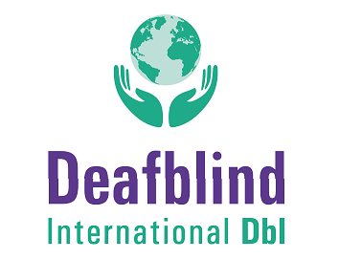

For further information, please contact:

International Society for Augmentative and Alternative Communication (ISAAC):
www.isaac-online.org

Appendix A.
Participation model incorporating ICF concepts

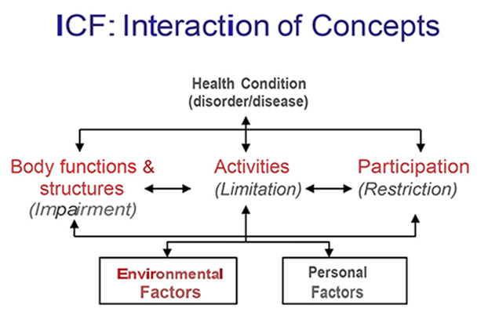

Appendix B.
Inclusive communication model
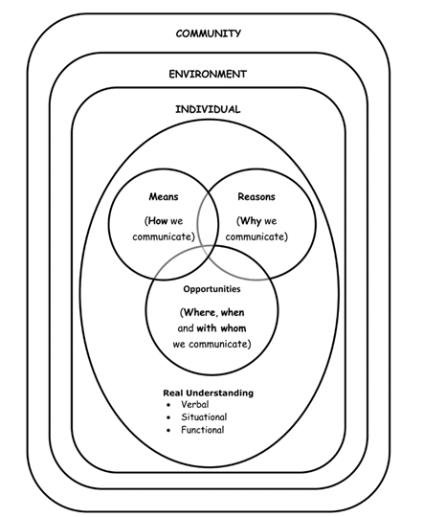

Money, D., Hartley, K., AcAnespie, L., Crocker, A., Mander, C., Elliot, A., . . . Tucker, S. (2016). Inclusive communication and the role of speech and language therapy. Retrieved from London: https://www.rcslt.org/speech-and-language-therapy/inclusive-communication-overview

