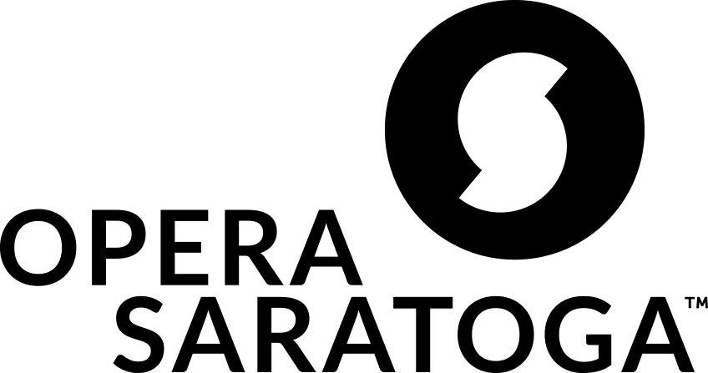

For Immediate Release:

Contact: Michelle Tabnick, 646-765-4773, michelle@michelletabnickpr.com

**RPI and Opera Saratoga collaborate:**

**THE OTHER SIDE OF SILENCE**

***A New Opera for Synthetic and Acoustic Voices***

**Wednesday, October 16, 2024 at 7 pm**

*Troy, NY (September 23, 2024) -* In a uniquely beautiful collaboration, Rensselaer Polytechnic Institute, Opera Saratoga, and the Bergamot Quartet join forces to present a free workshop performance of THE OTHER SIDE OF SILENCE by librettists Mark Steidl and Katherine Skovira and composer Robert Whalen. THE OTHER SIDE OF SILENCE is a new opera for synthetic and acoustic voices written by and for people who use Alternative Assistive Communication.

The story draws direct inspiration from the life of Mark Steidl, a gender non-binary person who uses an Augmentative and Alternative Communication (AAC) device to talk with the world. The cast also includes Opera Saratoga favorites Meghan Kasanders (*The Consu*l, 2017) and Jennifer Zetlan (*Ellen West*), as well as newcomers Theo Hayes and Isaiah Musik-Ayala.

This workshop performance is presented as part of the 2024 International Symposium On Assistive Technology For Music And Art (ISATMA).

**Synopsis:**

Zari, who struggles with seizures and, who was born with disabilities and unable to speak through traditional means, finds comfort from struggle in their home from the "Lichttanz" or the magical play of light and shadow through a window.

In an effort to gain more autonomy, Zari seeks help from a new technology designed by Olympus Realities. Despite opposition from their closest friends and family, Zari pursues this technology, hoping for a positive outcome. The technology called Chimera, or Kim, earns Zari's trust over time.

A medical emergency prompts an intervention where it is discovered that Olympus Realities has, without Zari’s express permission, installed an implant in Zari to help build communication between their brain and Kim. Zari fights back against this control and eventually disrupts the connection between the implant and Kim, though unfortunately after many of Zari's memories have already been edited and manipulated. The one memory, however, that Kim is unable to alter, is that of the “Lichttanz”, representing the infinitude of human capacity and self-knowledge, their inner strength that withstands the intervention of artificial intelligence.

THE OTHER SIDE OF SILENCE examines the intersection of art, advocacy, and technology in our lives, memories, and identities, and the role that art plays in promoting equity and agency of those who use alternative means of communication to speak to the world.

**Artistic Team:**

Mary Birnbaum, director

Katherine Skovira, co-librettist

Mark Steidl, co-librettist

Robert Whalen, composer

Sara Pyszka, consultant

**When:**

**Wednesday, October 16, 2024 - 7 pm**

The performance is free and open to the public.

**Where:**

**Concert Hall at the**

**Curtis R. Priem Experimental Media and Performing Arts Center (EMPAC)**

**50 8th Street**

**Troy, NY 12180**

More information will be sent to registrants as the date approaches.

For more information and to reserve tickets, please visit <https://lp.constantcontactpages.com/ev/reg/fdf3797>

**Robert Whalen** (he/him/his) serves as Lecturer of Music and Conducting at Rensselaer, where he directs the Rensselaer Orchestra, Concert Choir, and Wind Symphony. Whalen has also led orchestras on the faculties of the University of Chicago as Director of the Chamber Orchestra and Lewis and Clark College as Interim Director of Orchestral Activities. At the University of Chicago, Whalen launched numerous innovative programs and projects, including an “Explore Classical Music!” alliance with the Berlin Philharmonic, a Graduate Student Composer Fellowship, and the Chamber Orchestra’s first-ever participation in the University of Chicago’s Humanities Day Festival.

A passionate advocate for contemporary music, Whalen is Co-Founder and Music Director of the Philadelphia-based ensemble SoundLAB. Of his work with SoundLAB, The Philadelphia Inquirer wrote, “The diabolical enthusiasm of...Robert Whalen left me nearly begging for mercy...the artistic equivalent of NASA’s New Horizons spacecraft.”

Whalen founded SoundLAB as the Barnes Ensemble in 2016 at the Barnes Foundation, where Whalen also served as Associate Curator for Music, the first curator of music in the 100-year history of the institution. The Barnes Ensemble has performed a diverse array of music by living composers and projects at the intersection of the arts, social justice, and technology. Whalen has collaborated with the Philadelphia Orchestra, the JACK Quartet, the Argus Quartet, the Curtis Institute of Music, the Barnes Foundation, Temple University’s Institute on Disabilities, the Free Library of Philadelphia, the American Philosophical Society, and with composers Chaya Czernowin, Zosha Di Castri, Clara Iannotta, Eric Wubbels, and Augusta Read Thomas. Under Whalen’s direction, SoundLAB was included at the International Contemporary Ensemble’s 2021 Ensemble Evolution Symposium, where industry thought leaders met to discuss and define trends in contemporary performance.

Access to music education and supporting young composers is core to Whalen’s work as a conductor and ensemble director. With SoundLAB, engaged over 1,000 students from the City of Philadelphia School District around Ligeti’s Ramifications in the inaugural Barnes Ensemble Festival in 2017. In the same year, Whalen began a partnership with the Temple University Institute on Disabilities and the Curtis Institute of Music’s Social Entrepreneurship program that cultivated a musical partnership between artists who use Alternative Assistive Communication and students at the Curtis Institute. This ongoing project has led so far to the premiere of two co-developed song cycles, lost time (2020) and __[no words]__ (2021).

Whalen’s conducting has been recognized in the US and internationally. He was personally selected by Lorin Maazel to serve as his Conducting Fellow at the Castleton Festival and has worked as Assistant Conductor at the WDR in Cologne, Germany. In addition to his instrumental work, Whalen also has significant experience working with the choirs. Whalen served as Assistant Chorus Master at Opera Philadelphia beginning in 2019 and has conducted the 64-voice professional chorus in preparations for productions of Prokofiev’s The Love for Three Oranges, Handel’s Semele, and Verdi’s Requiem. During his tenure at the Barnes Foundation, Whalen also served as Director of the Choral Series and Guest Conductor of the Philadelphia Voices in a performance of Einojuhani Rautavaara’s Vigilia, which was praised by the Philadelphia Inquirer: “…programs this thoughtfully conceived and confidently executed are always needed in even the richest of musical communities.” Whalen has also held the Choral Conducting Fellowship at Yale University’s Norfolk Chamber Music Festival.

Whalen earned a BA cum laude from Cornell University, where he studied composition with Pulitzer Prize-winning composer Steven Stucky. Whalen was awarded an MFA in Orchestral Conducting from the Bard College Conservatory of Music, and a DMA from the University of Minnesota, where he studied with Craig Kirchhoff.

**Katherine Skovira**, D.M.A. (she/her) is a nationally recognized contemporary music

specialist, educator, researcher, curator, and mezzo-soprano from Philadelphia.

Katherine has collaborated on numerous projects with composer/conductor Robert

Whalen. Of their work, The Philadelphia Inquirer wrote, “The diabolical enthusiasm of

Robert Whalen and Katherine Skovira left me nearly begging for mercy...the artistic

equivalent of NASA’s New Horizons spacecraft.”

Katherine serves as Faculty Fellow in Music at Rensselaer Polytechnic Institute in Troy,

NY and Co-Artistic Director of SoundLAB contemporary ensemble in Philadelphia and

she has performed with Maestro Lorin Maazel, Sir Simon Rattle, and Barbara

Hannigan, and has collaborated with the Philadelphia Orchestra, Curtis Institute,

Lucerne Festival, JACK Quartet, Institute on Disabilities at Temple, American

Philosophical Society, American Composers Forum, University of Pennsylvania, and

Alarm Will Sound. Katherine holds degrees in voice, pedagogy, and political science

from Cornell University, Westminster Choir College, and the University of Minnesota

School of Music.

Katherine is co-librettist for the new opera, *The Other Side of Silence,* which workshops

with Opera Saratoga in 2024 at EMPAC as part of the International Symposium on

Assistive Technology for Music and Art (ISATMA) and Opera Saratoga’s Listen to This:

Voice to Heal Our Future Series. Katherine received the 2021 Discovery Grant for

Female Composers and additional grants from Opera America’s New Works Forum,

Foundation for Contemporary Arts, and New Music USA. She has presented at

conferences with Opera America, the Voice Foundation in 2023 and 2024, and the

National Association of Teachers of Singing. Since 2017 and 2023 respectively,

Katherine has worked with innovators in the non-speaking community and people with

spinal cord injury in collaborative performances and research/educational initiatives.

Katherine has performed over 32 world premieres of new solo vocal and operatic works.

**Mark Steidl** (he/they) is a disability rights advocate and 2020 graduate of Community College of Allegheny County, where he majored in Social Work Foundations and served as a student government senator. Mark was diagnosed as an infant with cerebral palsy and uses a variety of technology to manage his condition. He serves on the board of directors of Disability Rights Pennsylvania, advocates in a variety of disability rights campaigns, and is a proud member of the LGBTQIA+ community. He works in Tech Support at Tobii Dynavox, a world leader in electronic communication.

**Opera Saratoga**, formerly known as Lake George Opera, began with a production of *Die Fledermaus* at the Diamond Point Theatre on July 5, 1962, playing to an audience of 230. The Company now calls Saratoga Springs home and performs for more than 25,000 people annually. Opera Saratoga celebrates its 60th Anniversary this season. The company serves the communities of Saratoga Springs, the Lower Adirondack and New York State Capital areas by providing access to world-class opera through the production of an annual Summer Festival, as well as year-round activities including extensive educational programs, mentorship of emerging operatic artists, and unique opportunities for the public to experience opera in both our home theater and non-traditional venues that leverage and embrace the unique cultural, historic, and natural resources of the area. To date, the company has performed 106 different fully staged works by 66 different composers, including 42 works by American composers and 14 premiere productions. In 2023, the company hired its 10th Artistic and General Director, Mary Birnbaum.

#